**Node JS Path module**

* Node js provides tou with the path module that allows you to intract with file paths easily.
* The path module has many useful properties and methods to access and manipulate paths in the file system.

First I have created one path folder and inside that I have created index.json

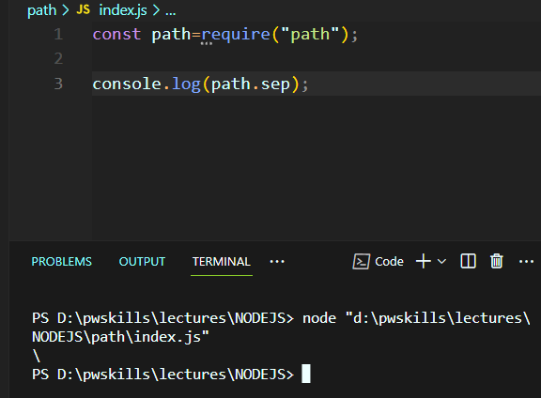

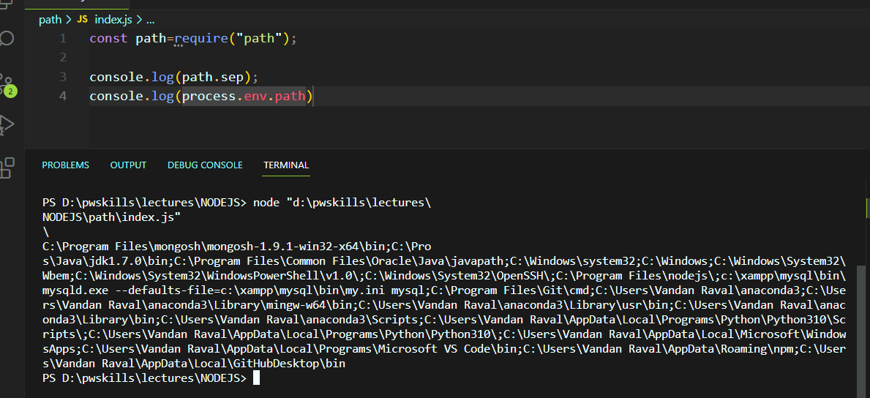

console.log(path.delimiter); *//output--->;*

**PATH MODLE**

Node js path module

dir

Name

Text

Base

ROOT

D:\ node.js\html\js \app.js

HANDY PATH METHODS

* THE following shows some handu methods of the path module that you probably use very often.

path.basename(path,[,ext])

path.dirname(path)

Path.extname(path)

path.format(pathObj)

path.isAbsolute(path)

path.join(…path)

path.normalize(path)

path.parse(path)

path.relative(from,to)

path.resolve.(...path)

//for find current path we use **“__filename”**

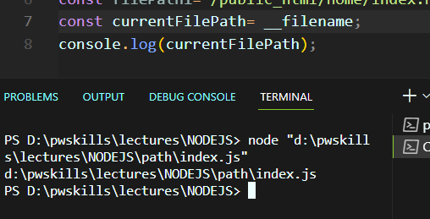

For get Dirname we use **“__dirname”(**it will not return only file name **)**

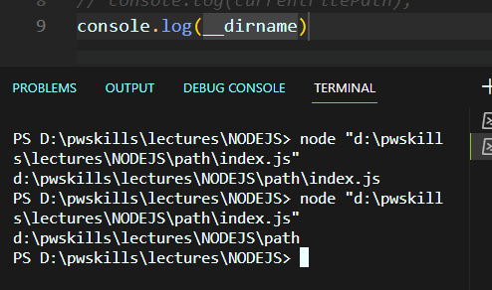

For find base name in current path with filename with extension

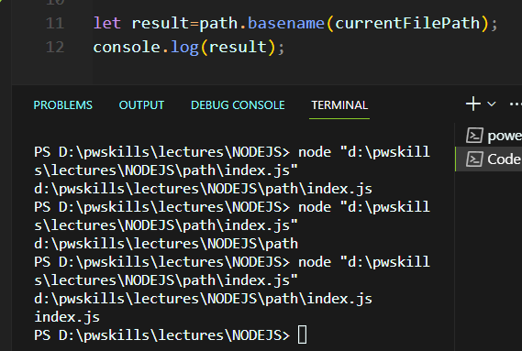

Using this we can get only file name without extension

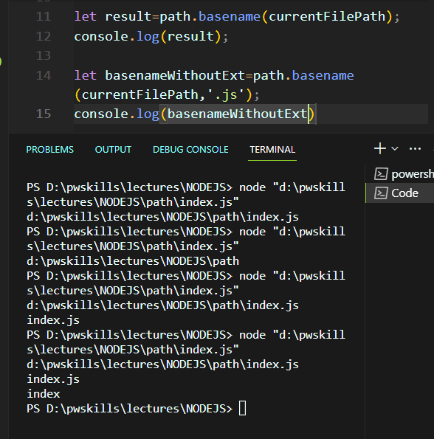

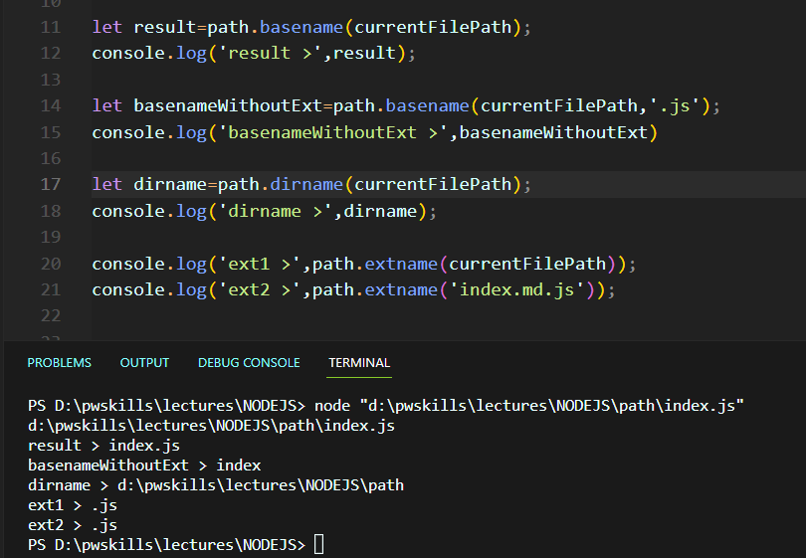

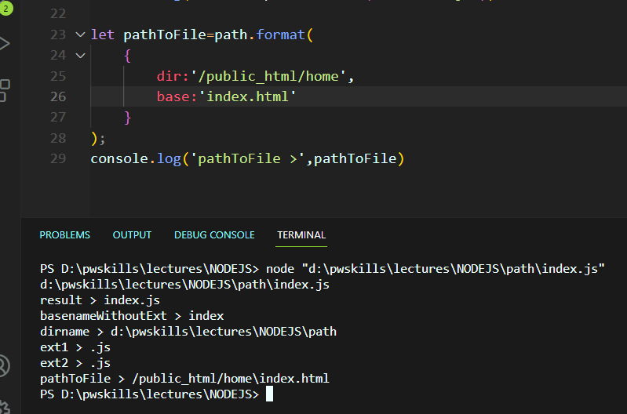

const path=require("path");

*// console.log(path.sep);*

*// console.log(process.env.path);*

const filePath1="/public_html/home/index.html";

const currentFilePath= __filename;

console.log(currentFilePath);

*// console.log(__dirname)*

let result=path.basename(currentFilePath);

console.log('result >',result);

let basenameWithoutExt=path.basename(currentFilePath,'.js');

console.log('basenameWithoutExt >',basenameWithoutExt)

let dirname=path.dirname(currentFilePath);

console.log('dirname >',dirname);

console.log('ext1 >',path.extname(currentFilePath));

console.log('ext2 >',path.extname('index.md.js'));

let pathToFile=path.format(

    {

        dir:'/public_html/home',

        base:'index.html'

    }

);

console.log('pathToFile >',pathToFile)

console.log("Is absulute:?",path.isAbsolute(currentFilePath)); *// true*

console.log("Is absulute:?",path.isAbsolute('/index.js')); *// true*

console.log("Is absulute:?",path.isAbsolute('./index.js')); *// false*

console.log("Is absulute:?",path.isAbsolute('../index.js')); *// false*

let pathToDir=path.join('/home','js','dist','index.js');

console.log("parhToDir>",pathToDir);*//parhToDir> \home\js\dist\index.js*

console.log('parse>',path.parse(currentFilePath));

*// parse> {*

*//     root: 'd:\\',*

*//     dir: 'd:\\pwskills\\lectures\\NODEJS\\path',*

*//     base: 'index.js',*

*//     ext: '.js',*

*//     name: 'index'*

*//   }*

console.log("relative path",path.relative('/home/user/config','/home/user/js/'))

*//op-->relative path ..\js*

console.log('resolve>',path.resolve());

*//op--->resolve> D:\pwskills\lectures\NODEJS*

console.log('Normalize>',path.normalize('//home//user//js'));

*//Normalize> \\home\user\js*